
Promoting Positive Behaviour

Our approach is based on mutual respect and trust, therefore we focus on establishing an understanding and caring relationship with each child similar to that which s/he experiences at home.

Children are also encouraged to develop caring and understanding relationships with each other, to be polite and helpful, to share and take turns and to respect other people’s cultures and beliefs.
We have a few clear and simple rules which everyone is helped to understand from the beginning and this helps to create a secure and happy nursery.

Some children can take a longer time than others to share, mix and settle and some do not always understand ‘give and take’. Some children may interpret an accidental bump as someone ‘hitting them’. Sometimes a child may lash out if another child takes a toy they are playing with.
Other children may hit out first because they misunderstand another child’s action or look and feel threatened by them.
A few children for no apparent reason may be angry or aggressive, hitting, scratching or biting other children.
In nursery, staff will make sure the child understands the effect his or her actions have had on another child. Sometimes a child needs to be redirected to another toy or activity or perhaps withdrawn from an activity to calm down. When this happens, staff remains close by and a child is never left alone.
Simple rules and consequences are detailed in the nursery Promoting Positive Behaviour document - available in the Parent Policy Folder.
Parents can help by keeping children’s nails short, by being firm and consistent at home and by working with nursery staff. If your child is unhappy please speak to staff.
Some children take a longer time than others to share, mix and settle and do not always understand the need to ‘give and take’ or share
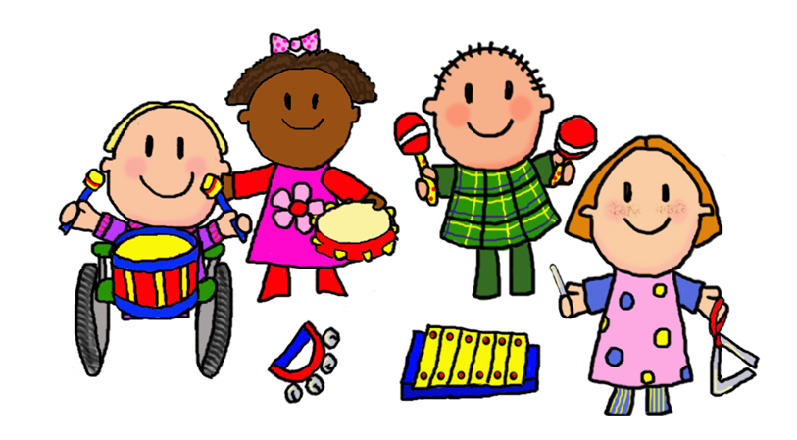

Toilet Training
We encourage children to be as independent as possible when going to the toilet and will provide assistance if necessary.
Whatever stage your child is at we will work with you to make sure your child is kept clean and comfortable and will support you to help your child to move towards independence.

Establishments may be affected by severe weather, power failures or difficulties with heating. If this happens we will do our best to let you know the details of the closure by telephone, on our website, in the press or on local radio.
Glasgow City Council’s website will also provide up to date information through their Twitter feed. You can also follow us on Twitter - LinthaughN

Glasgow City Council

Education Services

Privacy Statement

As the local authority our schools and early years establishments process information about children and young people in order to help administer education and care. In doing so we must comply with the Data Protection Act (1998).
This means (amongst other things) that the data held about children and young people must only be used for specific purposes allowed by law. The following information explains the types of data held, why that data is held, and to whom it may be passed on.

You also have the right to take your complaint or suggestion direct to the Care Inspectorate.
They can be contacted as follows:

Glasgow City Council Going to School Website
www.glasgow.gov.uk/en/residents/goingtoschool

Our Local Councillors:
Local MP’s and MSP’S

Westminster Parliament
Chris Stephens MP
Scottish Parliament
Johann Lamont MSP (Constituency)
Humza Yousaf MSP (Glasgow List)
Greater Pollok Ward 3

Councilor Saqib Ahmed
Councilor Rashid Hussain
Councilor David McDonald
Councilor Rhiannon Spear

Phone:
0141 287 2000
Ask for the
Councillors corridor.

Although this information is correct at time of printing, there could be changes affecting any of the matters dealt with in the document:
a) Before the commencement or during the course of the establishment year in question;
b) In relation to subsequent establishment years.

